**Chapter 2**

**Vectors in Space**

**2.4 The Cross Product**

**Section Exercises**

**For the following exercises, the vectors  and  are given.**

1. **Find the cross product of the vectors  and  Express the answer in component form.**
2. **Sketch the vectors  and **

183.  

Answer: a. 

b.

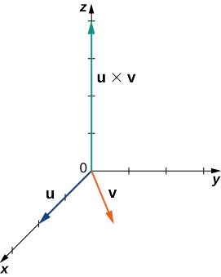

185. , 

Answer: a. 

b.

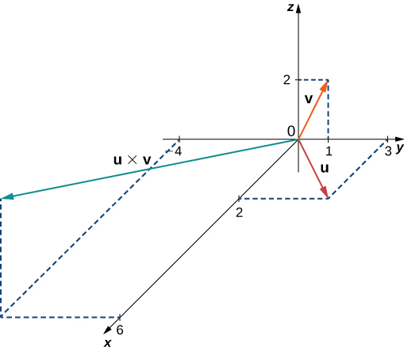

187. Simplify 

Answer: 

**In the following exercises, vectors  and  are given. Find unit vector  in the direction of the cross product vector  Express your answer using standard unit vectors.**

189.  

Answer:

191.   where   and 

Answer: 

193. Determine the real number  such that  and  are orthogonal, where  and 

Answer: 

195. Show that  is orthogonal to  and  where  and  are nonzero vectors.

Answer: This is a proof; therefore, no answer is provided.

197. Calculate the determinant 

Answer: 

**For the following exercises, the vectors  and  are given. Use determinant notation to find vector  orthogonal to vectors  and **

199.   where  is a real number

Answer: 

201. Find vector  where   and 

Answer: 

203. **[T]** Use the cross product  to find the acute angle between vectors  and  where  and  Express the answer in degrees rounded to the nearest integer.

Answer: 

205. Use the sine and cosine of the angle between two nonzero vectors  and  to prove Lagrange’s identity: 

Answer: This is a proof; therefore, no answer is provided.

207. Nonzero vectors  and  are called *collinear* if there exists a nonzero scalar  such that  Show that  and  are collinear if and only if 

Answer: This is a proof; therefore, no answer is provided.

209. Find the area of the parallelogram with adjacent sides  and 

Answer:

211. Consider points  and 

1. Find the area of parallelogram  with adjacent sides  and 
2. Find the area of triangle 
3. Find the distance from point  to line 

Answer: a.  b.  c. 

**In the following exercises, vectors  are given.**

1. **Find the triple scalar product **
2. **Find the volume of the parallelepiped with the adjacent edges **

213.  and

Answer: a. b. 

215. Calculate the triple scalar products  and  where   and 

Answer: 

217. Find vectors  with a triple scalar product given by the determinant

 Determine their triple scalar product.

Answer:    

219. Consider the parallelepiped with edges  and  where  and 

1. Find the real number  such that the volume of the parallelepiped is  units3.
2. For  find the height  from vertex  of the parallelepiped. Sketch the parallelepiped.

Answer: a.  b. 

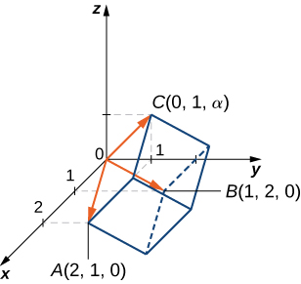

221. Let  bethree-dimensional vectors and  be a real number. Prove the following properties of the cross product.

1. 
2. 
3. 
4. 

Answer: This is a proof; therefore, no answer is provided.

223. Nonzero vectors  are said to be *linearly dependent* if one of the vectors is a linear combination of the other two. For instance, there exist two nonzero real numbers  and  such that  Otherwise, the vectors are called *linearly independent*. Show that  are coplanar if and only if they are linear dependent.

Answer: This is a proof; therefore, no answer is provided.

225. Consider points    and  Are vectors   and  linearly dependent (that is, one of the vectors is a linear combination of the other two)?

Answer: Yes,  where  and 

227. Let  and  be two-dimensional vectors. The cross product of vectors  and  is not defined. However, if the vectors are regarded as the three-dimensional vectors  and  respectively, then, in this case, we can define the cross product of  and . In particular, in determinant notation, the cross product of  and  is given by



Use this result to compute  where  is a real number.

Answer: 

229. Determine a vector of magnitude  perpendicular to the plane passing through the axis and point 

Answer: 

231. Consider  and  two three-dimensional vectors. If the magnitude of the cross product vector  is  times larger than the magnitude of vector  show that the magnitude of  is greater than or equal to  where is a natural number.

Answer: This is a proof; therefore, no answer is provided.

233. Find all vectors  that satisfy the equation 

Answer:  where  is any real number

235. **[T]** A mechanic uses a -in. wrench to turn a bolt. The wrench makes a angle with the horizontal. If the mechanic applies a vertical force of  lb on the wrench handle, what is the magnitude of the torque at point  (see the following figure)? Express the answer in foot-pounds rounded to two decimal places.

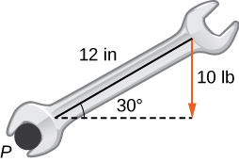

Answer: 8.66 ft-lb

237. **[T]** Find the magnitude of the force that needs to be applied to the end of a cm wrench located on the positive direction of the axis if the force is applied in the direction  and it produces a  N⋅m torque to the bolt located at the origin.

Answer: 250 N

239. **[T]** The force vector  acting on a proton with an electric charge of  (in coulombs) moving in a magnetic field  where the velocity vector  is given by  (here,  is expressedin meters per second,  is in tesla [T], and  is in newtons [N]). Find the force that acts on a proton that moves in the plane at velocity  (in meters per second) in a magnetic field given by 

Answer: 

241. **[T]** Consider  the position vector of a particle at time  where the components of  are expressed in centimeters and time in seconds. Let  be the position vector of the particle after  sec.

1. Determine unit vector  (called the *binormal unit vector*) that has the direction of cross product vector  where  and  are the instantaneous velocity vector and, respectively, the acceleration vector of the particle after  seconds.
2. Use a CAS to visualize vectors   and  as vectors starting at point  along with the path of the particle.

Answer: a. 

b.

­ 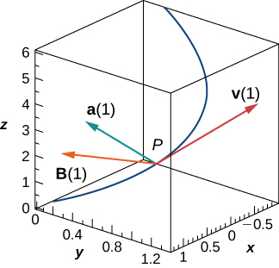

This file is copyright 2016, Rice University. All Rights Reserved.